3D Printed Universal Cutting Frame

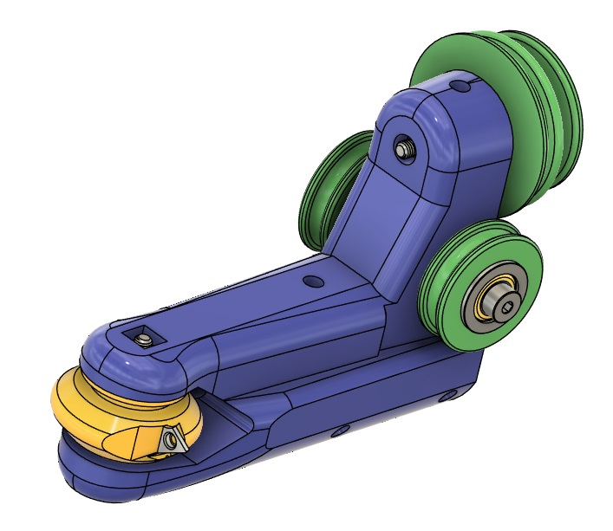

Parts List
QTY | Description
2 | Shoulder bolt: M4x10(M3 thread 6mm long)
1 | Shoulder bolt: M4x20(M3 thread 6mm long)
1 | Shoulder bolt: M5x25(M4 thread 6mm long)
2 | M695ZZ bearing
6 | M104ZZ bearing
6 | M4 Bearing Shim: 4x7x0.2
5 | M4 Washer:4x9x0.8
1 | M5 Bearing Shim:5x7x0.2
1 | M5 Washer:5x10x1.1
9 | M3 square nut: 5.3x5.3x2.2
1 | M4 nut
6 | M3x6 Set screw
1 | Steel rod 16mmx120mm
1 | TDHB07T1202 Insert
1 | 1/8" Carbide rod: Minimum length 1"
1 | Round Poly belt: 2mm
 | 3D printed parts
1 | Main body
1 | Cutter head: 1/8" (Brass or steel optional)
1 | Insert cutter head: CW
1 | Insert cutter head: CCW
2 | Idler pulleys
1 | Double pulley
1 | Double pulley spacer
1 | Sharpening jig: 1/8" 60 degrees
1 | Sharpening jig: 1/8" 120 degrees
 | Tools
 | Metric Allen wrenches: 1.5, 3
 | Tap: 2.2mm

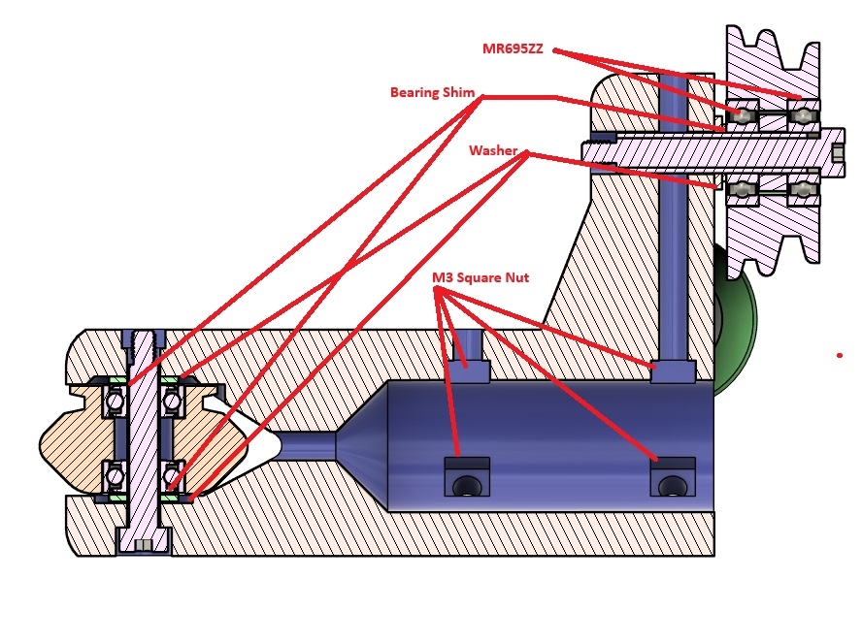

Cutter heads

Insert head
- Carefully tap the insert hole with 2.2mm tap. Don’t tap deeper than 4.5mm.
- Attach the insert. It will be a tight fit. Do not over tighten the locking screw.
- Press one MR104 bearing into the head.
- Add the cutterhead spacer.
- Press the second bearing into the head.
- Bearing shims and washers need to be held in place on the main arm. A drop of CA glue can help.
- Slide the cutterhead into position and secure with the M3x20 shoulder bolt and M3 square nut.

1/8” engraving bit head
- Tap the locking screw hole with M3 tap.
- Install the engraving bit. The hole may need to be reamed or drilled first.
- Install the locking M3 set screw. Do not over tighten.
- Install the bearings with the cutterhead spacer between them.
- Add the bearing shims and washers to the main arm.
- Install the cutterhead.

Idler Pulleys
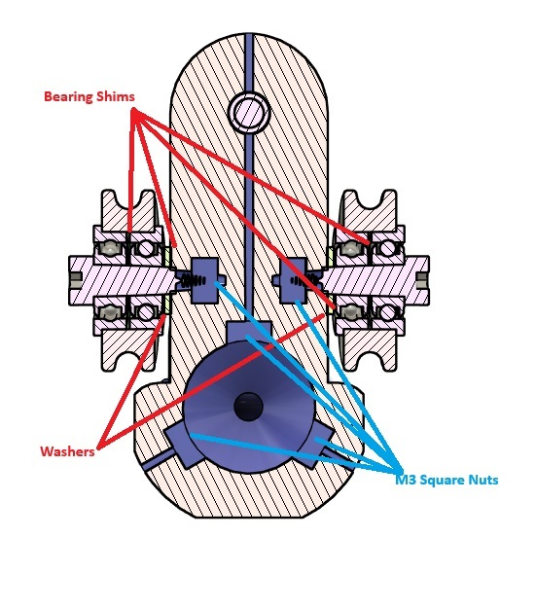
- Press the MR104ZZ bearings into the idler pulleys with two 0.2mm bearing shims between them.
- Press M3 square nuts into the openings at the back of the main arm.
- Attach the idler pulleys to the main arm using M4x10 shoulder bolts, bearing shims, and washers.

Shaft
- Insert M3 square nuts into the shaft opening. Note: CA glue the inner three nuts to a short rod and use a long M3 screw to pull the nuts into their holes.
- Insert the 16mm diameter shaft and secure with six M3 set screws.

Drive pulley
- Install the MR695ZZ bearings and double pulley spacer into the double pulley.
- Install the pulley using an M5x25 shoulder bolt, bearing shim, and washer. Use a washer and nut to secure it. Note: The larger diameter pulley is next to the main arm.
- Attach the 2mm round poly belt.

3D printer slicer settings
- Walls: 8
- Infill: 40% Cubic
- Brim: 15mm
- Filament: ABS-GF for the main body and pulleys. ABS for the cutterheads and sharpening jigs.
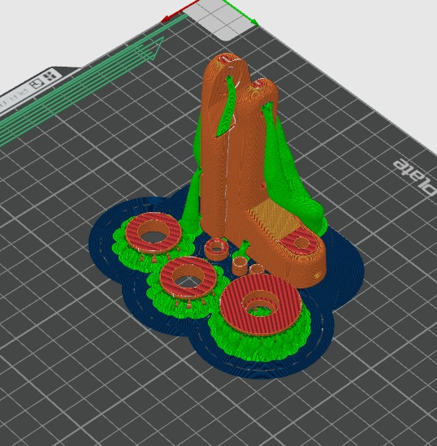

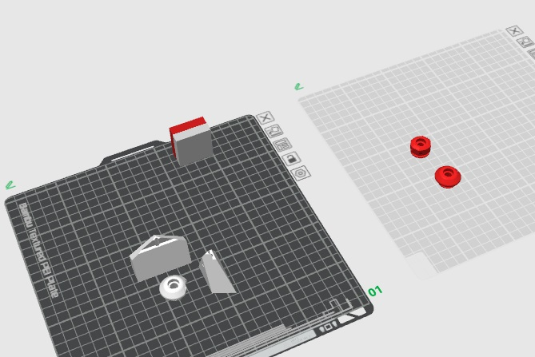

Notes:
The pulleys and cutterhead should move freely.
The bearings in the pulleys may get hot to the touch when first running. This seems to diminish over time.
Do not take heavy cuts.
Models for clockwise and counterclockwise insert cutterheads are included as well as a model for 1/8” bits.
Sharpening jigs for 60 degree and 120 degree engraving bits are included.

